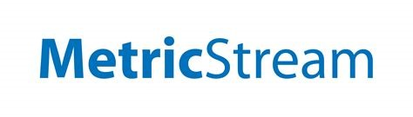



WHITE PAPER:

AI and Contract Management

Summer 2020

**Collaboration By:**

**MetricStream and Golden Gate University**

By Brandon Pak & Saloni Jain

**Foreword**

       The age of artificial intelligence has made tools more accessible than ever before. Organizations are automating manual processes to achieve quicker time to insight and eliminating the tediousness of repetitive tasks. In the realm of Contract Lifecycle Management, organizations are utilizing natural language processing to extract relevant contract information to ensure information veracity and to capture anomalies that manual review might miss.

**About Us (Golden Gate University ~ MetricStream Collaboration)**

**MetricStream** is an independent market leader in enterprise cloud applications for governance, risk, compliance (GRC), and quality management. Through the enterprise platform and cloud software, MetricStream enables enterprises across industries to drive exceptional business performance based on the foundation of good governance, trust and integrity.

Founded in 1901 in San Francisco, **Golden Gate University** offers undergraduate and graduate programs in business and management, accounting, taxation, and law.

**Contract Lifecycle Management**

   Contracts are a legally binding agreement. Two different parties, such as companies, enter contracts usually to exchange of goods and services for currency. The starting point of a contract’s life is usually a contract template for contracts entered into many times with different parties. The terms of the contract are sometimes negotiated between two parties and agreed upon. Once agreement occurs, the final contract version is signed and both parties are responsible for delivering what they agreed to in the contract. The legal department at a company usually drafts the contract before it is negotiated but contracts entered can impact many departments of a company. For example, sales, finance, and accounting, operations, supply chain, manufacturing and more. The life of a contract continues through to amending a contract, renewal, or termination of a contract. Contract Lifecycle Management is the management of the contracts through the process of initiation through execution, performance and renewal/expiry.

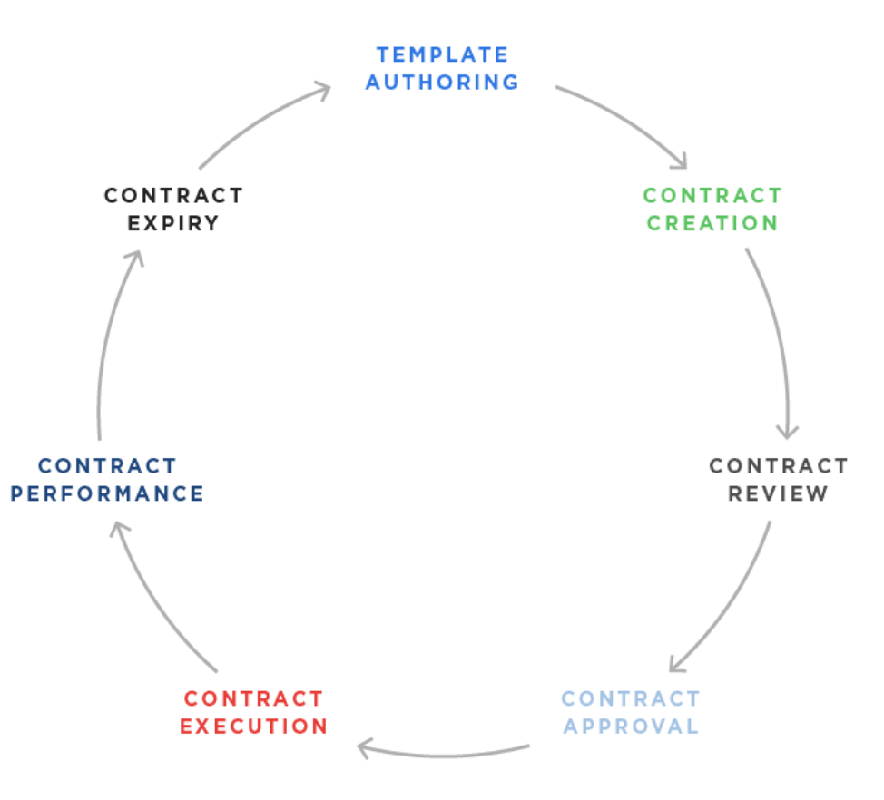  
  
*Figure 1:* Steps in the Contract Lifecycle Management

The correct CLM solution connects the contracts process to order fulfillment and billing, eliminating errors, reducing risk and ensuring that revenue can be forecasted more accurately.

**Artificial Intelligence and Contract Management**

                Key terms and conditions in a contract typically include the contract name (i.e. the type of contract), the parties involved, effective date, any fees and / or rates, contract milestones, renewal or termination dates, and so on.Companies must understand the key terms and conditions after signing a contract to ensure that they are meeting their responsibility, especially as the company grows and enters more and more contracts. If they do not, they may incur legal fees, financial obligations, unsatisfied customers, early termination of contracts, and much more.

      In order to track these key terms and conditions, the company may manually input all that information somewhere to track it, such as into a system or spreadsheet. As the variety and number of contracts entered increases, the more time-consuming and tedious this task becomes. Importantly, customers may negotiate changes to the standard template which must be tracked and met on an on-going basis. This is how contract lifecycle management (CLM) becomes challenging. If this process is not well managed, a customer may not be billed or underbilled, a contract renewal may be missed, the services rendered may not meet a service-level agreement noted in the contract, or worse.

One solution to this problem is to automate the extraction of key words and phrases in contracts so that they are all shown in one file or output. These key words and phrases will be categorized by the relevant actor who is responsible for this area. For example, if a clause is mainly related to finance or a service-level agreement then a team member on one of those teams or both should know about it and take appropriate action. Using this type of output, employees may be assigned tasks and be more aware of deliverable requirements before, during, and after the products and/or services are rendered, contracts that may be expiring soon, and more.

CLM is one use case in extracting key data from sometimes lengthy documents**,** includingMicrosoft Word documents or PDFs, and turning them into actionable insight potentially saving the company time and money in the process. Thistype of automated data extraction can be applied to other documents, such as lease agreements, line of credit agreements, invoices, purchase orders, financial statements, and so on.

**Introduction to Machine Learning**

 Machine Learning is an application of Artificial Intelligence (AI) that helps the system to automatically learn, perform and improve from experience. Machine Learning focuses on the development of the computer programs that can access the data and use it for themselves. **Primary aim is to allow the computers to learn automatically without human intervention and act accordingly.**  Machine Learning enables analysis of massive quantities of data, while generating faster and more accurate results in order to identify profitable opportunities or dangerous risks pertaining to the organization. Combining ML with AI and cognitive technologies can make it even more effective in terms of processing large volumes of information.

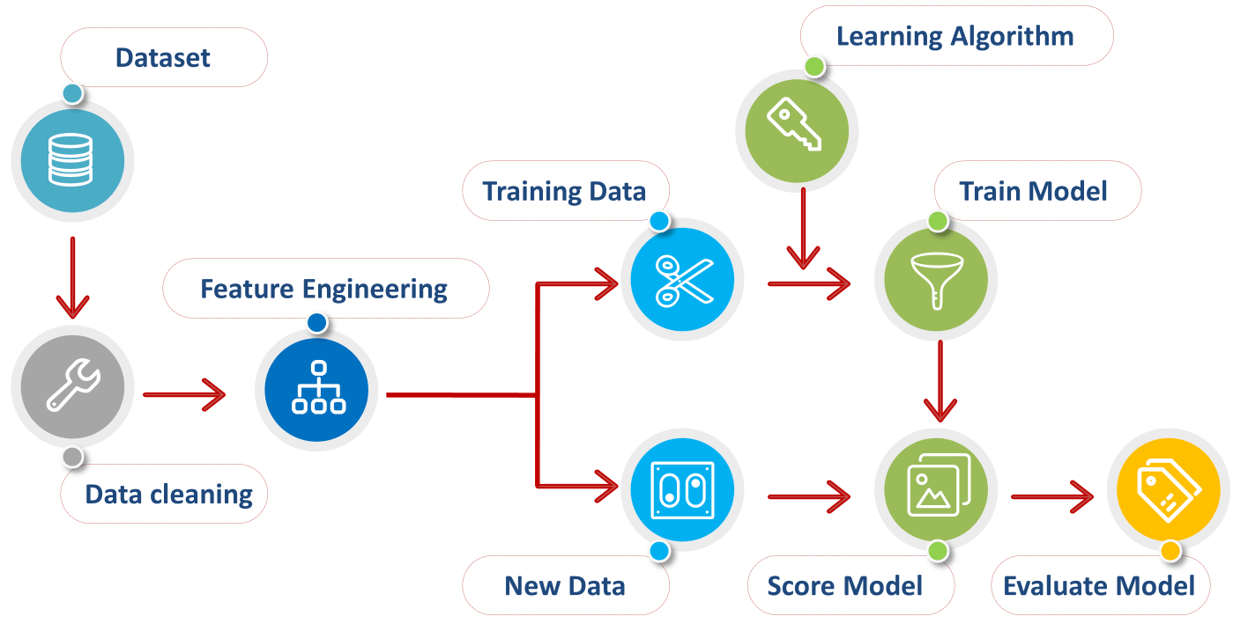

*Figure 10: Machine Learning Process overview*

It is very important for companies who practice CLM to understand the importance of applying Machine Learning combined with AI and produce customized outputs and perform the analysis.

**Usefulness of Machine Learning Model to MetricStream**

Aside from the benefits of automating manual processes, machine learning is especially useful in domain specific oddities. Contracts often use highly specific terminology to define an action or state. Contracts are structured with odd breaks in lines and use a variety of punctuation and characters. Capturing all these structural issues in a set of rules can be difficult, but through machine learning, these oddities can be dealt with via training a contract specific model.

The out-of-box natural language processing components of the “spacy” library are utilized in several sections throughout our tool pipeline. Firstly, “sentencizer” is a natural language processing tool that breaks a document into sentence-like chunks rather than on specific demarcations. Named entity recognition uses specific data labeling that can be used to extract relevant metadata terminology. Dependency parsing looks at the relationship between words and aids in grabbing relevant terminology based on its relationship to other relevant terminology. Synonym usage and lemmatization allows us to broaden search and capture the relevant metadata terminology as it appears in contracts.

These out-of-box tools can be further trained and specialized towards our contracts as we generate labeled training sets for our model. This will further strengthen our tool the longer it is used.

|  |  |
| --- | --- |
| “Sentencizer” | Breaks up document into sentence-like chunks |
| Named Entity Recognition | Label words with entity tags |
| Dependency Parser | Displays relationship between words |
| Synonym and Lemmatization | Finds synonym and similar words for search |

**Progress to Date (Use cases of AI and Contract Management)**

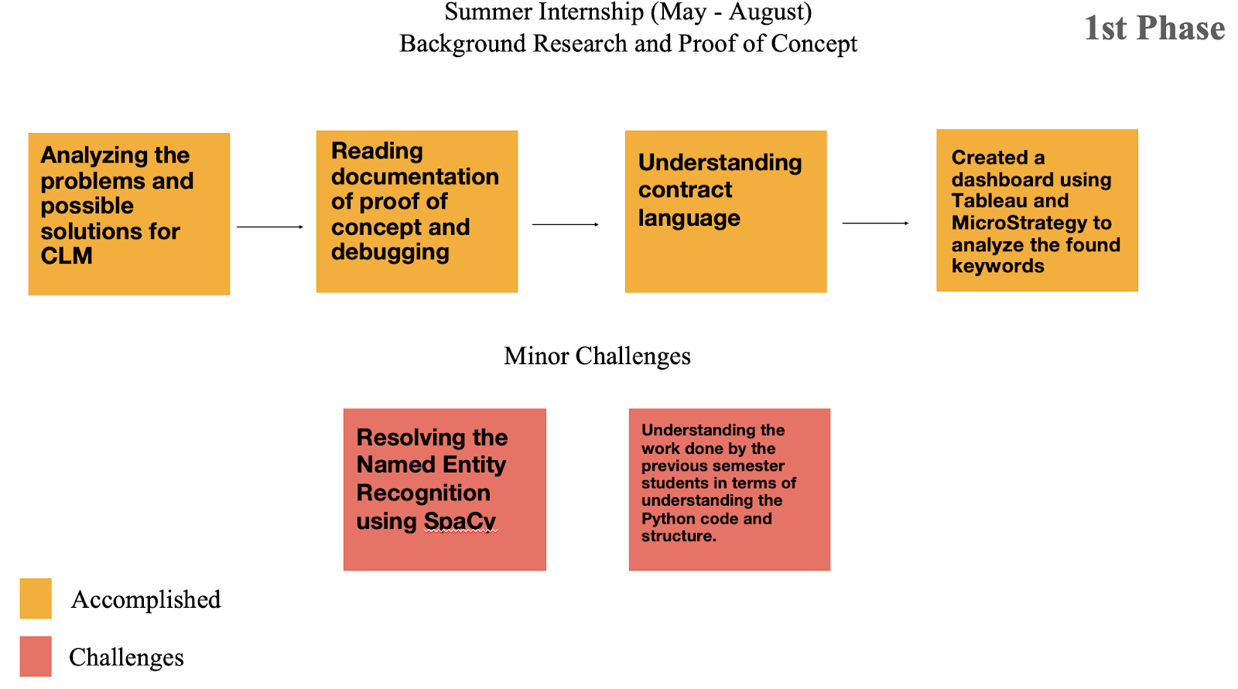

*Figure 2: Starting Point*

This phase highlights the initial stage of our internship wherein we were trying to understand the work done by the previous semester students as well as analyzing the possible problems and solutions for the contract lifecycle management. We read the documentation of the proof of concept and debugged the errors from the Python code/structure to suit the requirement. By gradually understanding the contract language, we created a drill down dashboard of the demo contracts using Tableau and MicroStrategy that helped us analyze the found keywords. Some minor challenges included resolving the named entity recognition using SpaCy library and deeper understanding of the work done by previous semester students in terms of the Python code and structure.

**Phase 2:**

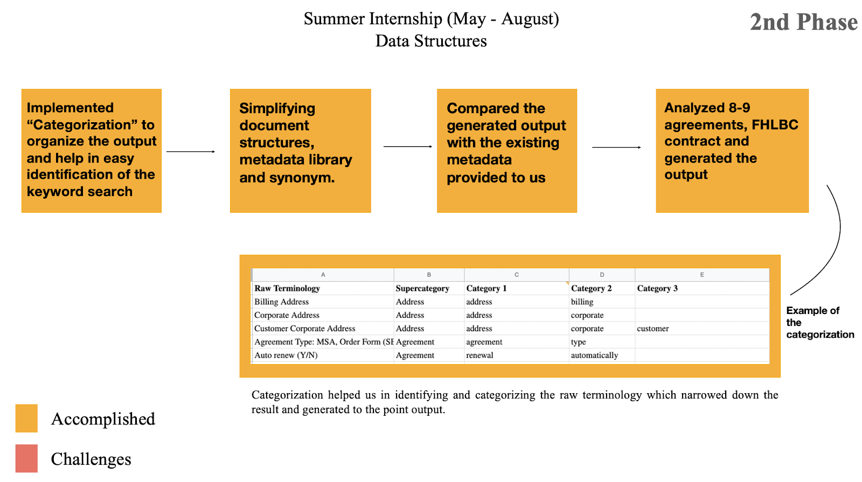

*Figure 3: 2nd Phase*

In this second phase, we concentrated categorizing various terminologies that will help us in the easy identification of the keywords search. Then we focused on simplifying the document structures and the metadata library. Categorizing the raw terminology narrowed down the result and generated the desired output.

**Overview of the Categorization List**

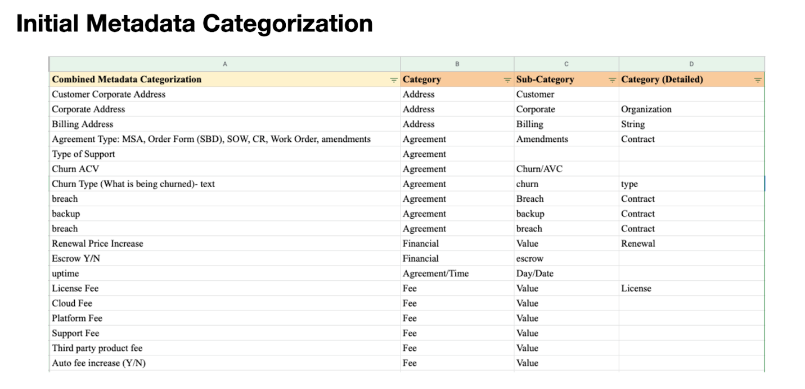

*Figure 6: Categorization List (Initial Metadata Categorization)*

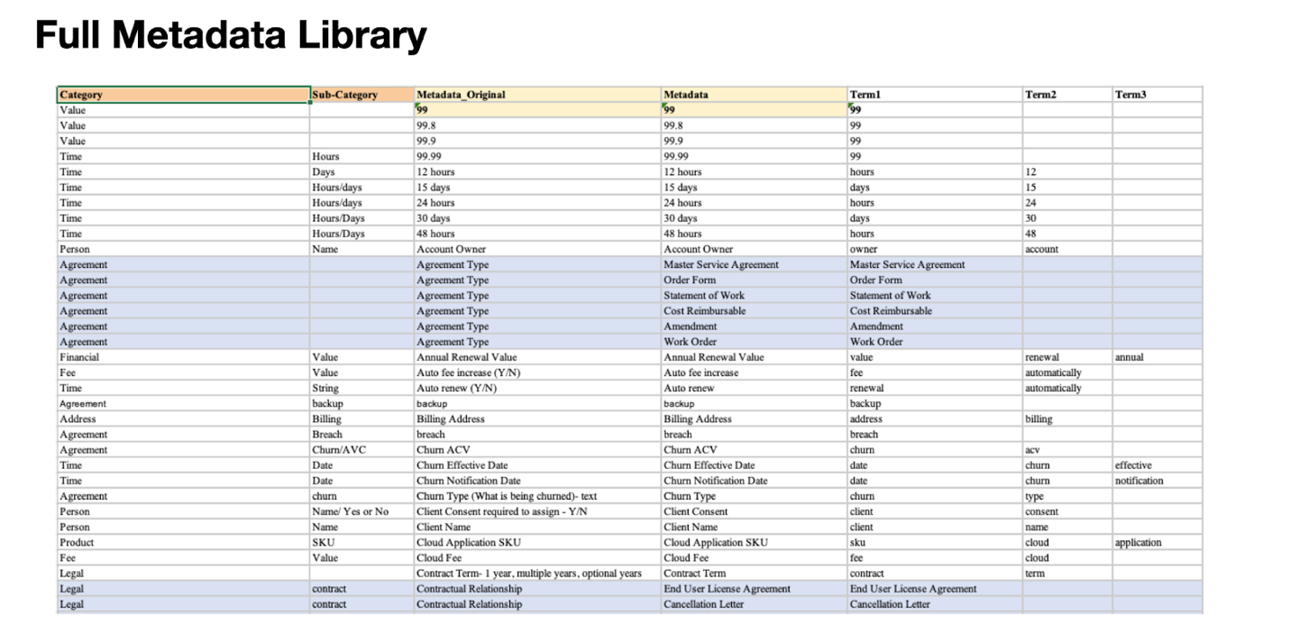

*Figure 7: Full Metadata library (including key terms and categorization)*

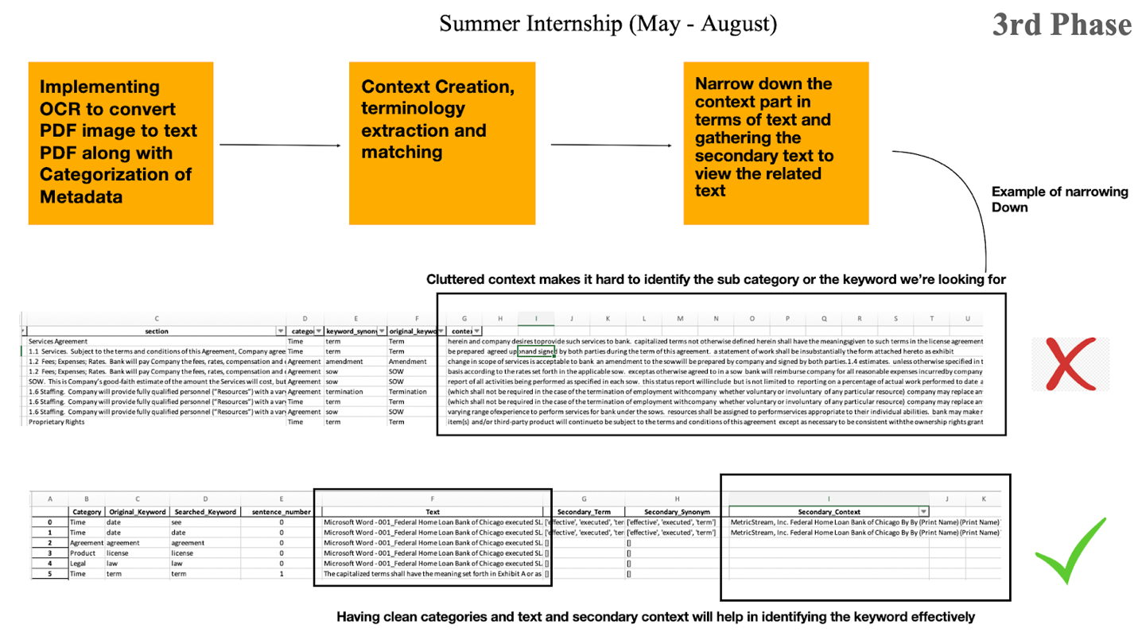

*Figure 4: 3rd Phase*

The third phase focused on narrowing down the context part of the output generated. The cluttered context made it hard to identify the categories as well as the keywords we were looking for. After running the code, the output generated had the text, secondary term, secondary synonyms and the secondary context. This was done in order to gather the surrounding text which the original text/context missed out. This gathering of the secondary text will help in better understanding of the output. `

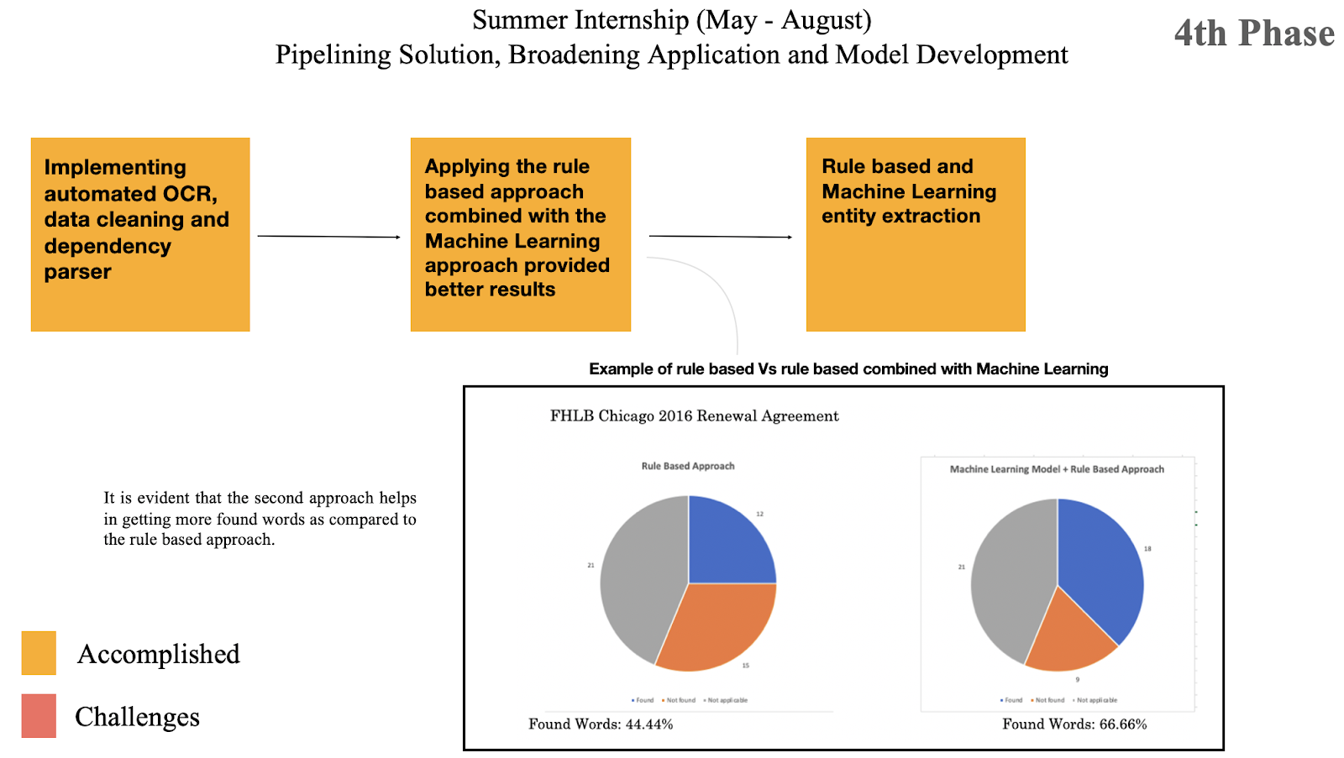

*Figure 5: 4th Phase*

This phase was more focused on implementing an automated OCR system. After implementing that, there were two approaches to provide the output: a) Rule based; b) Rule based combined with Machine Learning entity extraction. After applying both the approaches, the results were better in the second approach (as mentioned in the figure).

**Overview of the Categorization List**

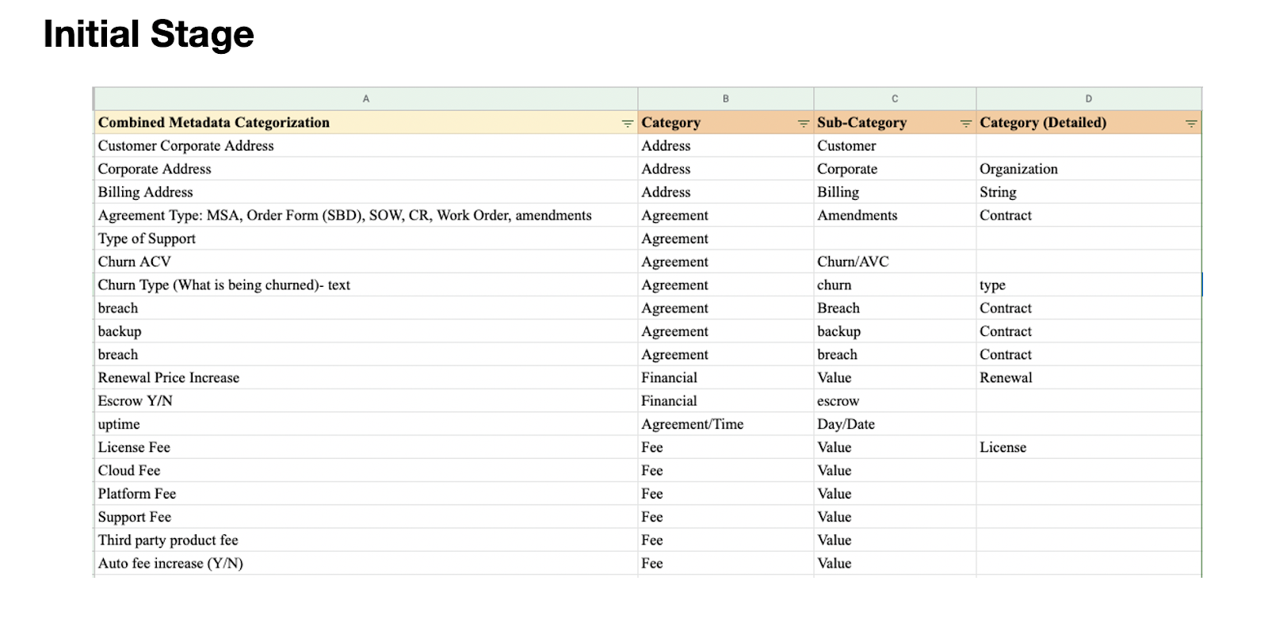

*Figure 6: Categorization List (Initial Stage)*

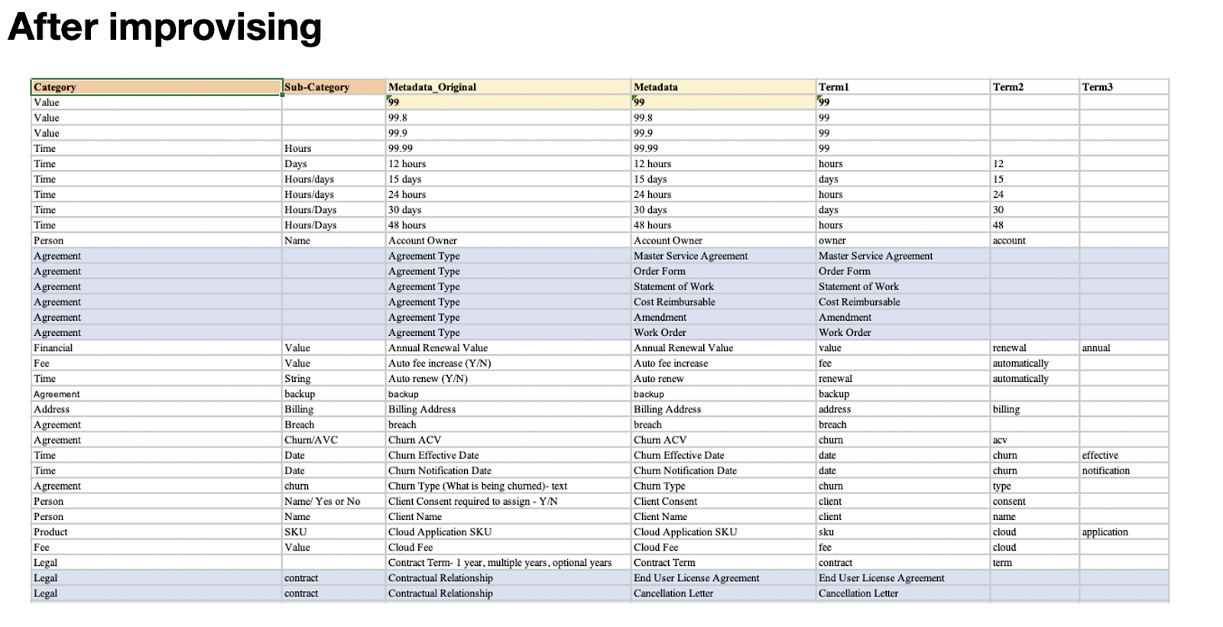

*Figure 7: Categorization List (After Improvising)*

**Sample work of the output**

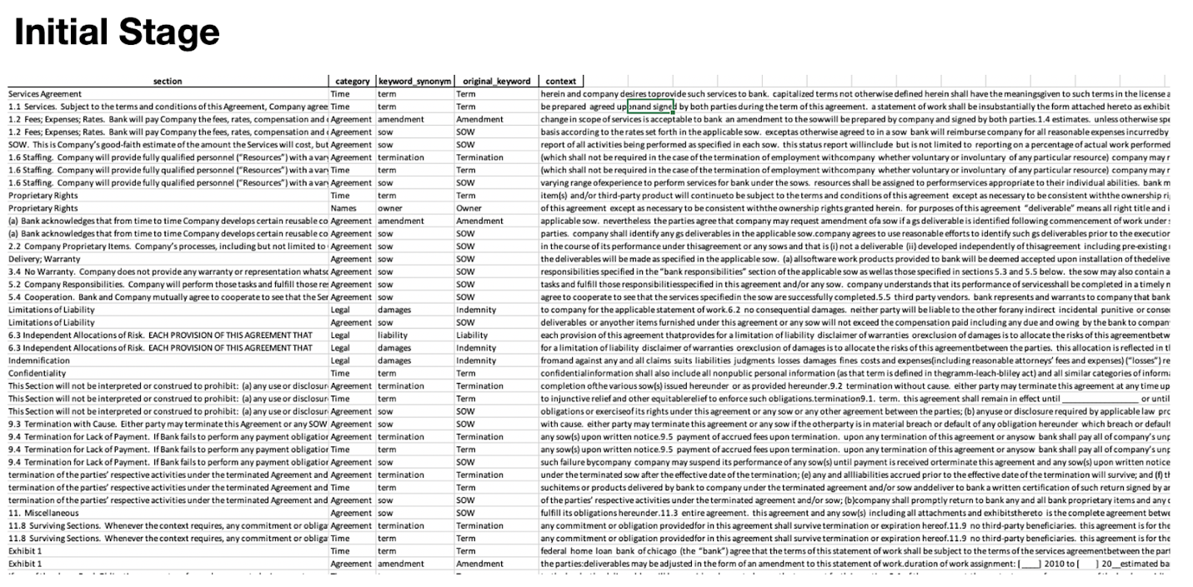

*Figure 8: Sample output (Initial stage)*

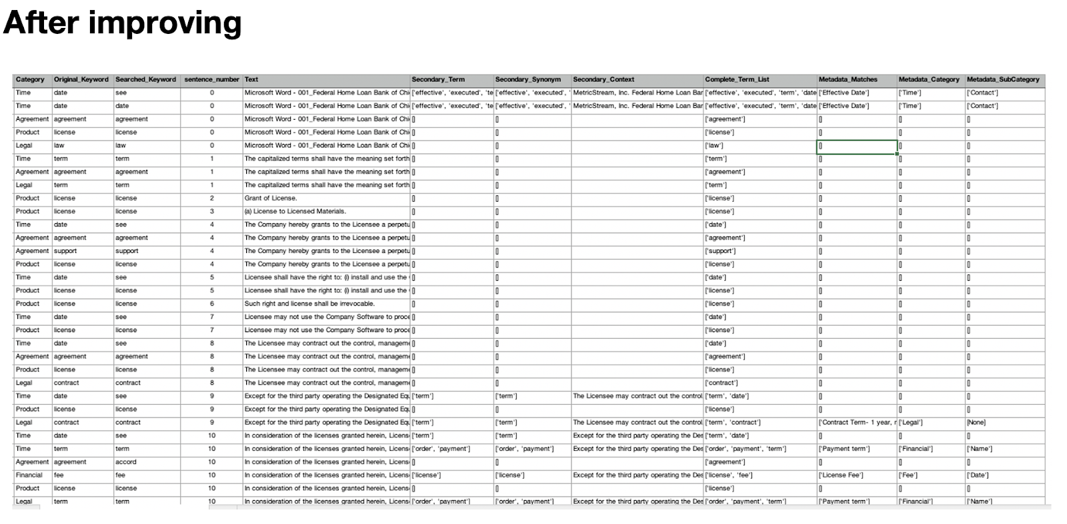

*Figure 9: Sample output (After improving)*

After improvising, we have categorized the metadata field into several columns such as category, original key word, searched keyword, text, secondary term, secondary synonym, secondary context etc which helped in gathering the surrounding text which the original context/synonym did not pick up. Apart from this, when this output was analyzed in Tableau, it not only helped in better understanding of the output but also gave it a cleaner look.

**Key Findings:**

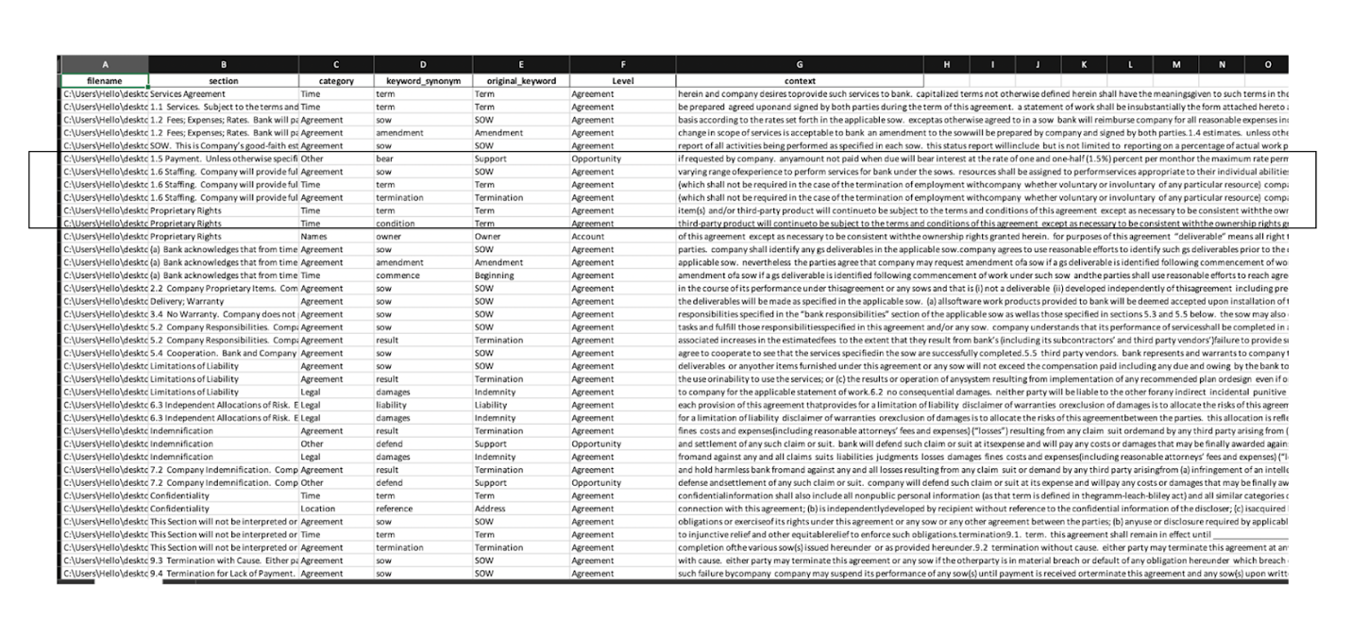

**Initial Stage:** In the initial stage, we were able to extract the section of the document along with its category, keyword synonym, original keyword and the context. The context section however needed to be changed and to be on point.

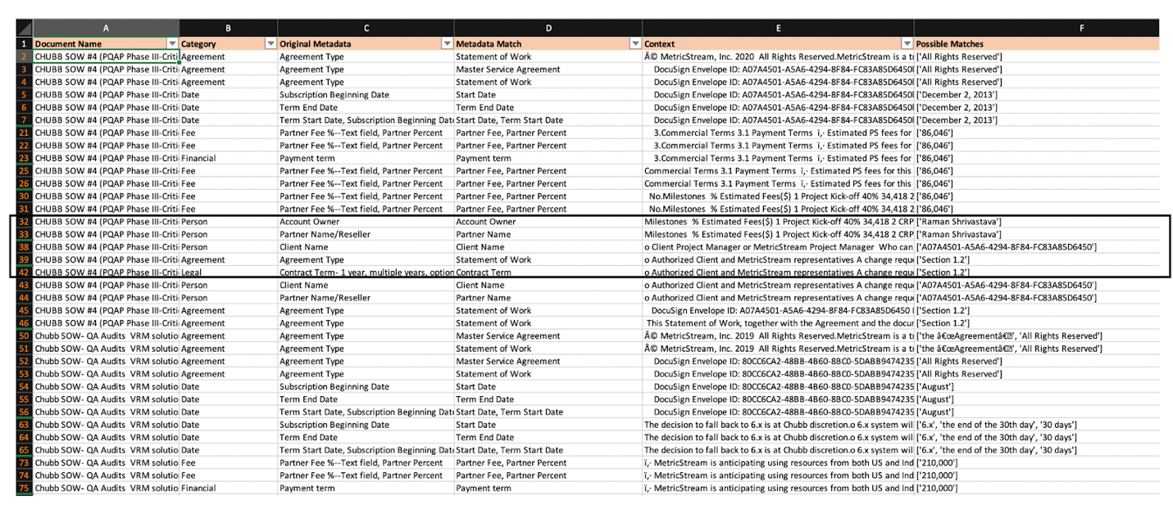

**Mid-Point:** In the mid-point, we focused on getting the possible matches which will help in identifying the keyword we’re looking for. For example, we want to know the Account Owner of which is mentioned in the contract, rather than reading the entire context, the possible matches helped us in identifying the account owner. One can surely read the context for more information.

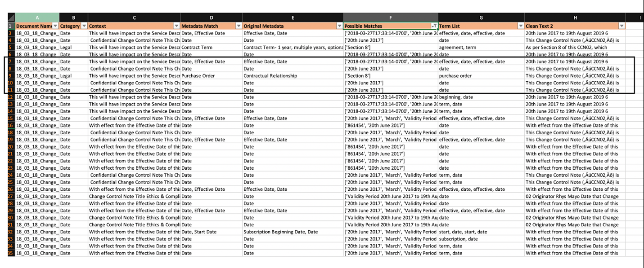

**End Point:** In the final stage, we focused on getting the outcome as precise as possible. For example, if we are looking for “effective date”, the outcome will help in identifying the possible matches (as date) and the term list. Along with the context, it also shows the clean text which helps in understanding the outcome in a better way.

As compared to the initial stage, we’re in a better position to identify the outcome. Instead of reading the entire context, we have the possible matches along with the context and the clean text.

**Tableau Dashboard**

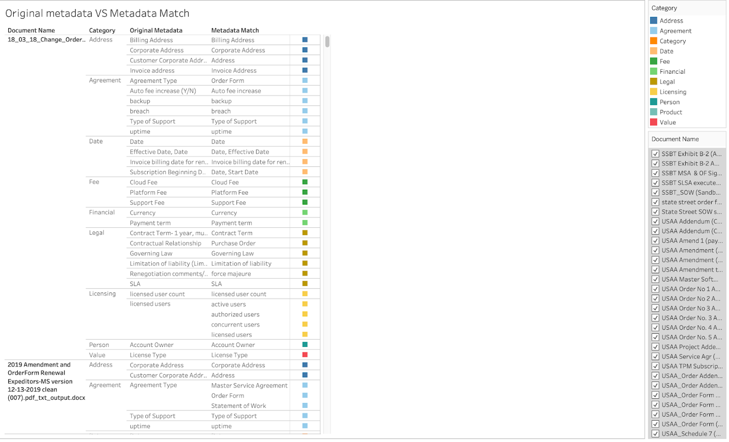

This dashboard focused on the Original Metadata Vs the Metadata Match. We categorized the terminology into various categories and assigned them metadata’s. This metadata was then matched by the original metadata and the outcome was as follows which had the context, along with the metadata matches and possible matches.

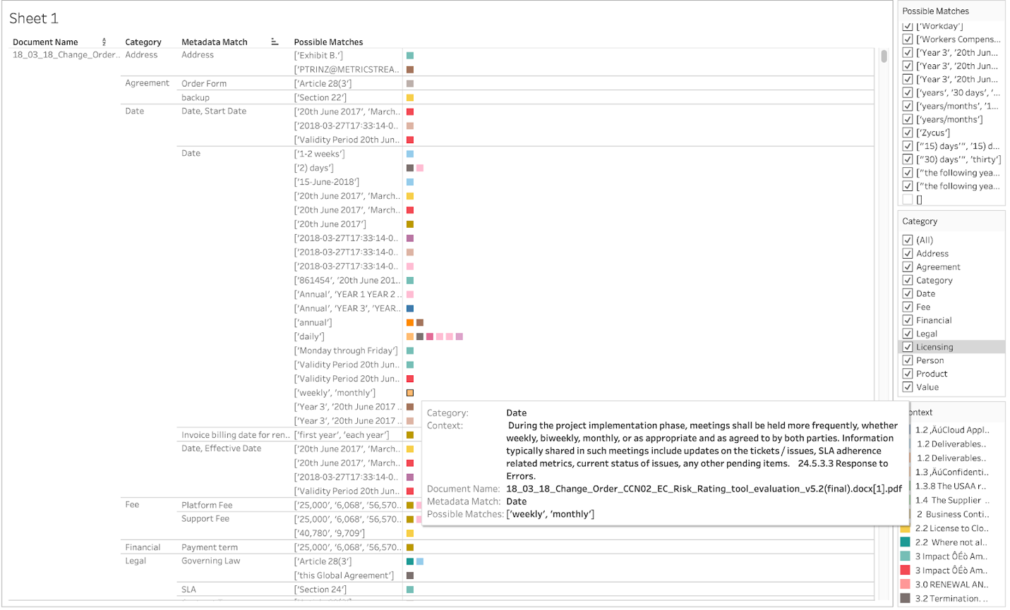

The aim of the dashboard is to be able to identify the categories we’re looking for according to the document/contract name and find the keyword/synonym. The dashboard helps us to select the category through the filter and find the context in the colored box for more reference.

**Conclusion**

Applying AI to CLM has already been occurring. In fact, AI can be used to manage a contract’s life from beginning to end. From drafting a contract, obtaining approval, alerting and reminding teams of action items on an on-going basis, and more. This can be done by integrating an automatic extraction algorithm with other systems such as a CRM system. Beyond applying automatic extraction to other types of documents (I.e. invoices, purchase orders, financial statements, etc.), this process can be pushed to the edge of computing, so that the extraction is performed locally.

**Roadmap for Next Semester and Future Work**

**1.) OCR Solution**

The current implementation of Tesseract OCR has several faults. Depending on document quality, the output text may be not be represented in text properly. If we continue to utilize open source technology, future work must be done to improve the text output. Improving the actual optical character recognition technology itself is not a feasible goal and therefore we are limited to what we are able to accomplish with the current output.

One feature of the current tool searches for characters that are clearly incorrect and either removes or replaces them.

Future work can look to implement a form of spell checking and word recognition to improve upon current text output.

**2.) Customization of metadata library and synonym finder**

Current metadata library consists of the initial set of metadata terms provided to us from the contract desk team. An exhaustive list is yet to be compiled. Adding new metadata fields is as easy as adding a new row to the metadata library excel file.

The terminology list and synonym finder however can be developed as well. For example, synonyms for words such as ‘date’ or ‘uptime’ may be relevant to our metadata field. However, synonyms for ‘cloud’ in our circumstances would not be relevant and therefore updating the synonym library to be exclusive to contract language may be an avenue worth exploring. The nltk wordnet synonym library contains a large database of synonyms and the current tool only makes use of up to 3 synonyms. In certain cases this is too many and in other cases, too few. A more sophisticated method of synonym usage may help in finding more diverse sets of text for a given metadata field.

**3.) Named Entity Recognition, Extraction, and the Dependency Parser**

Named entity recognition applies labels to words. For example, it will look for dates and apply the tag DATE. In simple cases, this feature of the spacy library works well. However, in cases that are more specific to contracts such as ‘limitation of liability’ the entity recognizer has no tag capable of finding relevant terms. The contract itself must be manually labeled as training data and fed into the spacy machine learning model updater so that these terms can be automatically labeled in the future.

The ability to automatically label very specific pieces of text allow the dependency parser to answer questions directly. While the current implementation of the spacy model allows one to label monetary values and extract them, if the nearby text is unclear about what the monetary value relates to, we must manually perform that. For example, a piece of text may contain the word ‘cloud fee’, ‘license fee’, ‘$10,000’, ’$20,000’. The tool can find these two words and two dollar amounts but determining which word relates to which dollar amount is a manual process. Training the dependency parser using user labeled data will allow the tool to automatically relate the correct term to the correct dollar amount.